**CHAPTER 1**

**INTRODUCTION**

**Introduction**

Business is one of the most important economy generators for each country and

Since the dawn of the twentieth century, all business companies turned to technology to better improve their business chances and qualities. Thus, such is the reason of the development of this system. This system is developed for the optical business, where it will be implemented in each of the shop outlets of an optical company. The system name is Smart Eyes Optics Shop (SEOS). The system is developed for the purpose of making management much more systematic, secure and efficient. SEOS consist of five *(5)* main modules which are registration and login, inventory management, transaction management, staff management, and financial management

The profitability of an optical retail store can depend on efficient operations and whether they have an optometrist practices in addition to selling glasses and contact lenses. Eye care practices need the right technology to provide the best patient care and customer service.  
**Point of Sale Software for Optician** helps you to manage your practice and maximize the efficiency of your patient encounters.  
Optimize your appointment schedules, exam encounters, sales orders and insurance billing with our optician software. Our inventory multi-office task solutions are powerful, efficient, and user friendly, because they have been designed with opticians in mind

Capabilities of five *(5)* main modules are described in the Table 1.1.

**Table 1.1: Modules and function list**

|  |  |
| --- | --- |
| **Module** | **Function** |
| Registration and login | * register and store clients, staff, branch and supplier information securely   - login to the system |
| Inventory Management | - manage the status information of products  - make statistic analysis on which products are selling  fast and have to make an order from particular supplier.  - purchase order can be made to order product and  delivery order can be made when deliver the product to the others branch |
| Sale Transaction Management | - select and sell the desired product quickly and  precisely  - collect the balance of the deposit payment  - view transaction receipt, product sales report, and personal sales report |
| Customer Record Management | -manages the customer Record of present and previous records  -help to informs about the debt collection |
| Financial/Billing Management | - manage the financial of the shop  - holding daily financial account to keep record on their earning |

**1.2 Optical Models of the Human Eye**

It is sometimes desirable in the computer analysis of the optical design of visual optical systems to incorporate a model of the human eye. Walker (2000) has described a model, illustrated in Fig. 15.2 with the data presented in Table 15.1. The pupil diameter is variable from about 2mm up to 6.0 mm, depending on the light illumination, but in this model a fixed average value of 4.0mm is assumed. The refractive index of the eye lens is not uniform. In this model the back surface of the eye lens is taken with a hyperboloid shape with a conic constant equal to _4.5 in order to simulate the no homogeneous refractive index of the eye lens. When numerically tracing rays in a computer to analyze the off-axis performance of a visual system to which this model of the eye has been

attached, the eye model has to be rotated about the center of the exit pupil

of the system being analyzed.

**Figure 1.2 Optical model of a human eye.**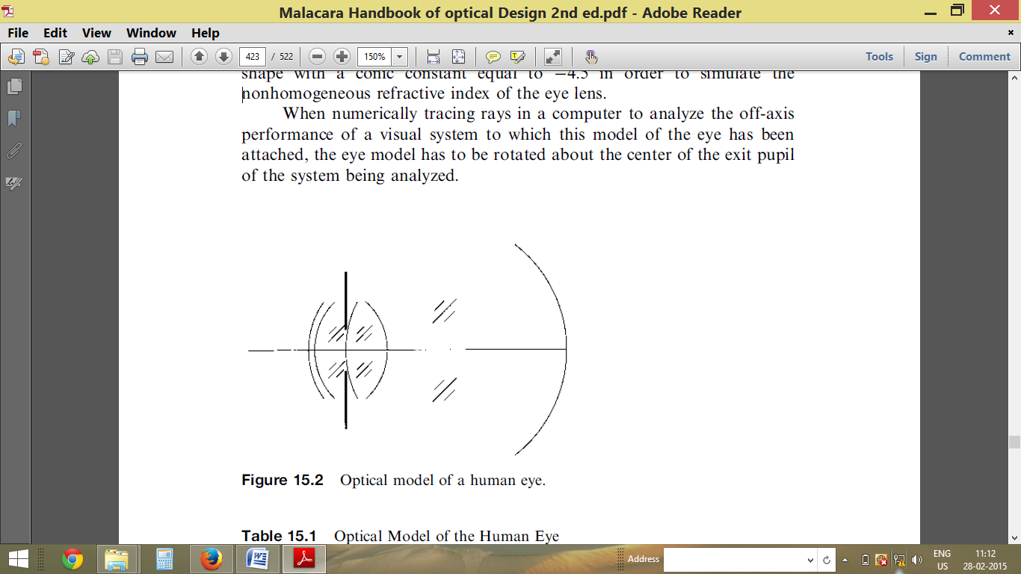

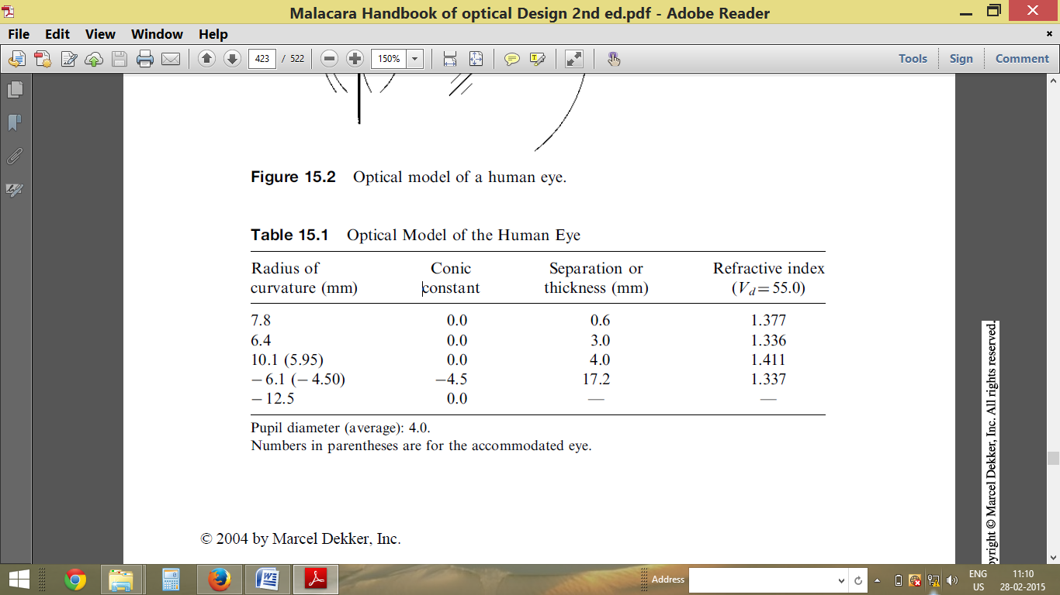

An alternative to avoid rotating the eye model for each off-axis point is to use as an eye model a system that produces good quality optical images on-axis as well as off-axis. The main requirements for this eye model is that the image size has an angular diameter much less than a minute of arc and Second. An example is a concave spherical mirror with a stop at its center of curvature and a spherical focal surface concentric with the mirror. The spherical aberration has to be small enough so that the angular diameter of the image is smaller than 1 arcmin. A mirror with a radius of curvature equal to 30.184mm (f¼15.092 mm) and 4mm diameter produces an image with a transverse spherical aberration equal to 1 arcmin. With a radius of curvature equal to 687.4mm the spherical aberration is 0.044 arcmin and a transverse aberration of 0.1 mm will correspond to an angular aberration equal to 1 arcmin.

**1.3 Existing System & Need For System**

* **Existing System**

The current system using now is manually system, means that all the process on managing the shop business flow is written in paperwork. During the transaction process, they just only use paper receipt but not printed receipt. Besides, they do not have any record on the customer profile, and staff profile. If they want to refer back their customer eye degree, they only can refer back the receipt that give to the customer before to get their previous record on the eye degree. If need to find out the receipt, they have to check it one by one, so it take quite a long time. Furthermore, the daily sell they record down on a log book and end of the month they have to calculate it manually. Adding for the staff commission, they also need to refer back they receipt one by one to calculate the total sell on the particular staff. These processes are time consuming by do it one by one. The shop does not have any well inventory management at the same time. Overall system flow is using traditional management system.

* **Apparatus**

Tools that are being used in this manual system include log book, receipt and pens. Log book which is use to record daily sell that written by pen. For the receipt, also is manually written by using pen. Appendix A is an outlook of the receipt they using now.

* **Analysis of Existing System**

This chapter is about the existing system that had been analyzed which is a

Optical shop management system.

This application is developed for optical shop to manage the business flow and consists of four main functions which are point of sale, front office, back office, and office manager.

**Need For System:**

The objectives to create OOSMS are:-

* To develop a computerized and systematic optical shop management system.
* To implement inventory management into the system to handle the stock

Management and keep record of the stock and customer information.

* Easy operations for operator of the system.
* No paper work requirement.
* Security is ensured by protecting the system with passwords.
* Normalized database tables eliminate data redundancy.
* Provision for minimizing errors in data entry.
* Reduce time consumption.

* Reduce error scope.
* All system managements are automated.

**1.4 Scope of Project**

* **Goals To Be Achieved :-**

1) Provides simple user interface

2) Easy to store the records.

3) Simple to understand.

4) Easy to manage the records.

* **Overview of Application :**

Optical Shop are the essential part of our lives, providing best glass, specs, lens facilities to people suffering refractive error from various , which may be due to change in climatic conditions, increased work-load, emotional trauma stress etc. It is necessary for the Optical Shop to keep track of its day-to-day activities & records of its customer, doctors, employee, salesman and other staff personals that keep the Optical Shop running smoothly & successfully.

But keeping track of all the activities and their records on paper is very cumbersome and error prone. It also is very inefficient and a time-consuming process Observing the continuous increase in population and number of people visiting the hospital. Recording and maintaining all these records is highly unreliable, inefficient and error-prone. It is also not economically & technically feasible to maintain these records on paper.

Thus keeping the working of the manual system as the basis of our project. We have developed an automated version of the manual system, named as “Automated Optical Record Keeping System”

The main aim of our project is to provide a paper-less hospital up to 90%. It also aims at providing low-cost reliable automation of the existing systems. The system also provides excellent security of data at every level of user-system interaction and also provides robust & reliable storage and backup facilities.

The Scope of the study to fully related with Optical System Management system.

The Software includes:-

_ maintaining Customer, stock and all necessary details.

_ Billing and Report generation.

**1.5 HARDWARE SPECIFICATION**

**Processor : Intel Pentium IV or More**

**RAM : 1GB**

**Keyboard : Standard 102 Keys**

**CD Drive : Samsung 52X CD/R**

**Hard Disk Drive : 20GB**

**Monitor : 15”SVGA (Color)**

**SOFTWARE SPECIFICATION**

**Operating system : Windows xp/7/8.0**

**Front-end : Microsoft Visual Studio C Sharp 2010**

**Back-end : SQL Server Compact 2008**

**CHAPTER 2**

**Proposed System**

**The main advantages of this proposed system are:**

**Shop aid (A Complete Point of Sale for Optical Business):**

 Using a combination of these two applications you can easily manage your N- number of multiple optical outlets from a centralized Head office. These two are one of the finest software presently in the optical industry to manage Opticians shop. The software is very user friendly so that opticians can very well handle their shop without any further hassle. Some of the features of the software are listed below:

**Customer Relationship & History**by their name, date of birth, mobile number, their prescriptions and previous purchases.

**Complete Inventory, Supplier/ Vendor Management** like purchases made from them and their stock available, etc.

**Stock management** of Optical products such as Frames, Sunglasses, Lens, Contact lens, and Contact lens solutions, many others

**Lens stock management** for various lens types like Plastic, Glass, and Polycarbonate of various powers like SPH, CYL, and AXIS.

**Contact lens** Management & its inventory

**Sales offer communication** to existing customers.

**Optometrist’s** module to enter prescription details of customer & instructions given

**Objective Proposed System:**

* Develop a clearer overview & greater control of your business
* Increase sales & improve profitability
* Streamline your processes & increase capacity
* Improve your productivity & sales opportunities

**2.2.1 Problem Analysis:**

The Transaction related to purchase, sale and return are maintained manually at present along with maintaining the account of Customers and suppliers

All these are to be automated and an application is required to relate all of them relatively and logically so that the current system can be replaced without major changes and problems.

The application should provide quick access to the records maintained must revert the important reviews about the business that the growth can be easily compared and should provide with various report showing the related details so that the important decision can be taken easily.

**2.2.2 Product Description:**

The project entitled “**OPTIC SHOP MANAGEMENT**” is the right solution for your practice because it is fully customizable and is designed to fulfill all your POS business need provide a managed remote and offsite backup service at a very affordable price to encrypt and backup your data.

**2.2.3**  **User Requirements:**

The application gives information regarding to history of Star Gas Agency. The administrator visiting to application can login and watch the database. Here in the database. After watching database administrator can update or delete the specified records from database.

2.3 ***Feasibility Study:***

* Assumptions

The Above design should work only for the Inventory Management System Application. However we make invoicing customer a breeze.  Using our program, you’ll find it easy to keep track of invoice details for each customer, accept deposits and payments, and maintain accurate accounts receivable records for your shop. Most realistic easily monitor, track and evaluate contact lens orders, enables the import of contact lens prescriptions along with a complete record of other past prescriptions within the Exam Module.

Boost the quality of service with the ability to correctly advise patients on necessary changes to their contact lenses. We have works closely with popular pretest vendors, which give us the ability to bring results directly from your equipment into your electronic exam – no more transcribing issues and no more wasted time.  Based on post exam results, you can configure the system to auto generate exam letters, spectacle job orders and contact lens job order.

* Risks

One of the major risks covered by this application is theft breaks synchronization between the inventory and the database. The Information could be generated by the data stored in this application .The confidence level of trusting data generated depends on the accuracy of the restocking procedure. Therefore we are facing a risk of reckless stock manager who could detriment the accuracy of the data.

* Technical feasibility:

My project is internally feasible as it work on the present equipment .Current procedure & exiting software technology as well as hardware & software is already available in present system thus my project is technically feasible.

* Fact Finding Techniques:

The best source for me was internet. I have viewed various application for sample helped me to create my application.

All the important information was also mentioned on various application from where approximate working of the system has been made by me.

I founded a bill example of an “Inventory System Shop” in which details were given which helped m in my project development.

I have also used other fact finding method as:

**Questionnaire**, **Record View, Observation, etc.**

* **COST AND BENEFIT ANALYSIS:**

Developing an IT application is an investment. Since after developing that application it provides the organization with profits. Profits can be monetary or in the form of an improved working environment. However, it carries risks, because in some cases an estimate can be wrong. And the project might not actually turn out to be beneficial.

Cost benefit analysis helps to give management a picture of the cost, benefits and risks. It usually involves comparing alternate investments.

Cost benefit determines the benefits and savings that are expected from the system and compares them with the expected costs.

In performing cost and benefit analysis it is important to identify cost and benefits factors. Cost and benefits can be categorized into the following categories:

1. **Development Costs –** Development costs is the costs that are incurred during the development of the system. It is one time investment.
2. **Operating Costs –** Operating Costs are the expenses required for the day to day running of the system. Examples of Operating Costs are Wages, Supplies and Overheads.
3. **Hardware/Software Costs –** It includes the cost of purchasing or leasing of computers and it’s peripherals. Software costs involve required S/W costs.
4. **Personnel Costs –** It is the money spent on the people involved in the development of the system.

**CHAPTER 3**

**Analysis Design**

**3.1 Data Flow Diagram**

**Context Level DFD:-**

*Stock Manage Advice*

*Employee*

*Record*

*Customer Complaint*

*Customer Status*

*Customer Appointment*

*Bill Payment*

***OPTIC’S EYES SHOP MANAGEMENT SYSTEM***

**First Level DFD:**

**DFD for Stock Manage Advice**

*Stock*

*Output Unit*

*Database*

**DFD for patient Appointment**

*USER*

*Output UNIT*



**DFD for Customer Search**

*Customer*

*Output Unit*

**Database**

**DFD For Bill Payment**

**Database**

*Accountant*

*Output Device*

*Customer*

**DFD For Login Of User**

*User*

*Output*

**Database**

**DFD For Maintaining Records for Customer and Stock**

USER

CustomerDbB

**3.2 ENTITY RELATIONSHIPDIAGRAM**

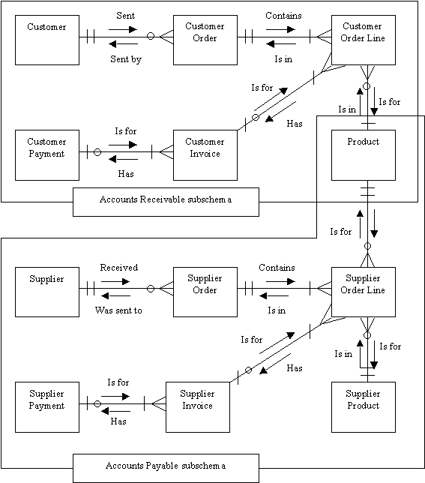

**An entity-relationship diagram for a POS system**.

**3.3 UML DIAGRAM**

Operation

:

enterItem

(

…

)

Post

-

conditions

:

-

**. . .**

**Operation Contracts**

Sale

date

**. . .**

Sales

LineItem

Quantity

1

..

*

1

**. . .**

**. . .**

**Domain Model**

**Use**

**-**

**Case Model**

**Design Model**

:

Register

enterItem

(

itemID

,

quantity

)

:

ProductCatalog

spec

=

getProductSpec

(

itemID

)

addLineItem

(

spec

,

quantity

)

:

Sale

*Objects*

*,*

*Attributes*

*,*

*Associations*

***Require***

***-***

***ments***

***Business***

***Modeling***

***Design***

:

System

enterItem

(

id

,

quantity

)

**Use Case Text**

System Sequence Diagrams

make

NewSale

()

*system*

*events*

Cashier

Process

Sale

:

Cashier

*use*

*case*

*names*

*system*

*operations*

Use Case Diagram

Vision

Supplementary

Specification

*Scope*

*,*

*Goals*

*,*

*Actors*

*,*

*Features*

*Non*

*-*

*Functional reqs*

*,*

*Quality attributes*

*Requirements*

*Process Sale*

1

.

Customer

Arrives

...

2

.

Cashier

makes new

sale

.

3

**3.4 STATE DIAGRAM**

Receive

Order

Fill Order

Send Invoice

Save

Order

Receive Payment

Close Order

**Fulfillment**

**Customer**

**Service**

**Finance**

Order

Invoice

Start

**Action**

.

It does something

.

There is an automatic

Transition on its completion

.

A

**transition**

supports

modeling of

**Control flow**

.

**Fork**

.

One incoming

Transition

,

And multiple

outgoing parallel transitions

and

/

or object flows

.

**Partitions**

.

Show different

Parties involved in the process

**Join**

.

Multiple incoming transitions and

/

or

object flows

;

one outgoing transition

.

The outgoing continuation does not happen

until

*all*

the inputs arrive from

*l*

flows

.

**Object Node**

.

An object

Produced or used by actions

.

This allows us to model

**Data**

**Flows**

or

**Object flows**

**.**

end of activity

|  |  |  |  |  |  |
| --- | --- | --- | --- | --- | --- |
| **Event** | **Trigger** | **Source** | **Activity** | **Response** | **Destination** |
| Adding  Customer | New  Customer | Admin/Employee | Recording New Product  Details | Customer  Details  Recorded | Admin |
| Adding  Product | New  Product | Admin/Employee | Recording  New Product  Detail | Product  Details  Recorded | Admin |
| Update  Order | Existing  Order  Need Change | Admin/Employee | Changing Order  Details | Order  Detail  Changed | Admin |
| Delete  Order | Delete | Admin/Employee | Deleting  Order  Details | Deleting  Details  Recorded | Admin |
| Take Details  Order | New Order | Admin/Employee | Recording  New  Order | Order Details  Recorded | Admin |
| Generate  Bill | Bill | Admin/Employee | Generating  Bill | Order | Admin |

**3.4 EVENT TABLE**

**CHAPTER 4**

**DATABASE DESIGN**

It is a process of designing the database file, which is the key source of the information in the system. The objective of database is to design is to provide storage and it contributes to the overall efficiency of the system. The file should properly design and planned for collection, accumulation, editing and retrieving the required information.

**Table Design**

## DATA MODELING:

**Customer table**

|  |  |  |  |
| --- | --- | --- | --- |
| **Field** | **Datatype** | Values | Constraint |
| Customerid | int | Not null | **Primary Key** |
| CustomerName | nvarchar(50) | Not null |  |
| Address | nvarchar(200) | Null |  |
| Nationality | nvarchar(50) | Null |  |
| DOB | datetime | Null |  |
| Mobile | numeric(15, 0) | Null |  |
| Appointment | datetime | Null |  |
| Email | nvarchar(100) | Null |  |
| Gender | nchar(10) | Null |  |
| DateOFVisit | datetime | Null |  |

**Product Table**

|  |  |  |  |
| --- | --- | --- | --- |
| **Field** | **Datatype** | Values | Constraint |
| ProductID | nchar(10) | Not null | **Primary Key** |
| ProductName | varchar(MAX) | Not null |  |
| CategoryID | int |  |  |
| SubcategoryID | int | Not null |  |
| features | nvarchar(200) | Null |  |
| Price | float | Null |  |
| Image | image | Not null |  |
|  |  |  |  |

Invoice Table

|  |  |  |  |
| --- | --- | --- | --- |
| **Field** | **Datatype** | Values | Constraint |
| OrderNo | nchar(30) | Not null | **Primary Key** |
| OrderDate | nchar(30) | Not null |  |
| Cust_ID | int | Not null |  |
| SubTotal | float | Not null |  |
| VATPer | float | Not null |  |
| VATAmount | float | Not null |  |
| DiscountPer | float | Not null |  |
| DiscountAmount | float | Not null |  |
| GrandTotal | float | Not null |  |
| TotalPayment | float | Not null |  |
| PaymentDue | float | Not null |  |
| PaymentType | nchar(100) | Not null |  |
| Status | nchar(100) | Not null |  |
| Remarks | varchar(250) | Null |  |

Supplier Table

|  |  |  |  |
| --- | --- | --- | --- |
| **Field** | **Datatype** | Values | Constraint |
| SupplierId | nchar(10) | Not null | **Primary Key** |
| SupplierName | varchar(250) | Not null |  |
| Address | varchar(250) | Not null |  |
| City | varchar(250) | Not null |  |
| ContactNo | nchar(15) | Not null |  |
| Email | varchar(250) | Null |  |
| Notes | varchar(MAX) | Null |  |
| ContactNo1 | nchar(15) | Null |  |

Employee Table

|  |  |  |  |
| --- | --- | --- | --- |
| **Field** | **Datatype** | Values | Constraint |
| Emp_ID | int | Not null | **Primary Key** |
| Name | varchar(150) | Not null |  |
| Address | nchar(100) | Not null |  |
| Phone No | nchar(30) | Not null |  |
| Picture | image | null |  |
| Email | nchar(60) | Null |  |
| Department | nchar(60) | Null |  |
| Designation | nchar(60) | Null |  |
| DateofJoining | nchar(30) | Null |  |
| Salary | nchar(10) | Null |  |
| BasicWorkingTime | nchar(10) | Null |  |
| YearofExperience | nchar(30) | Null |  |
| DOB | nchar(30) | Null |  |
| Gender | nchar(10) | Null |  |

**USER INTERFACE DESIGN**

SPLASH FORM:

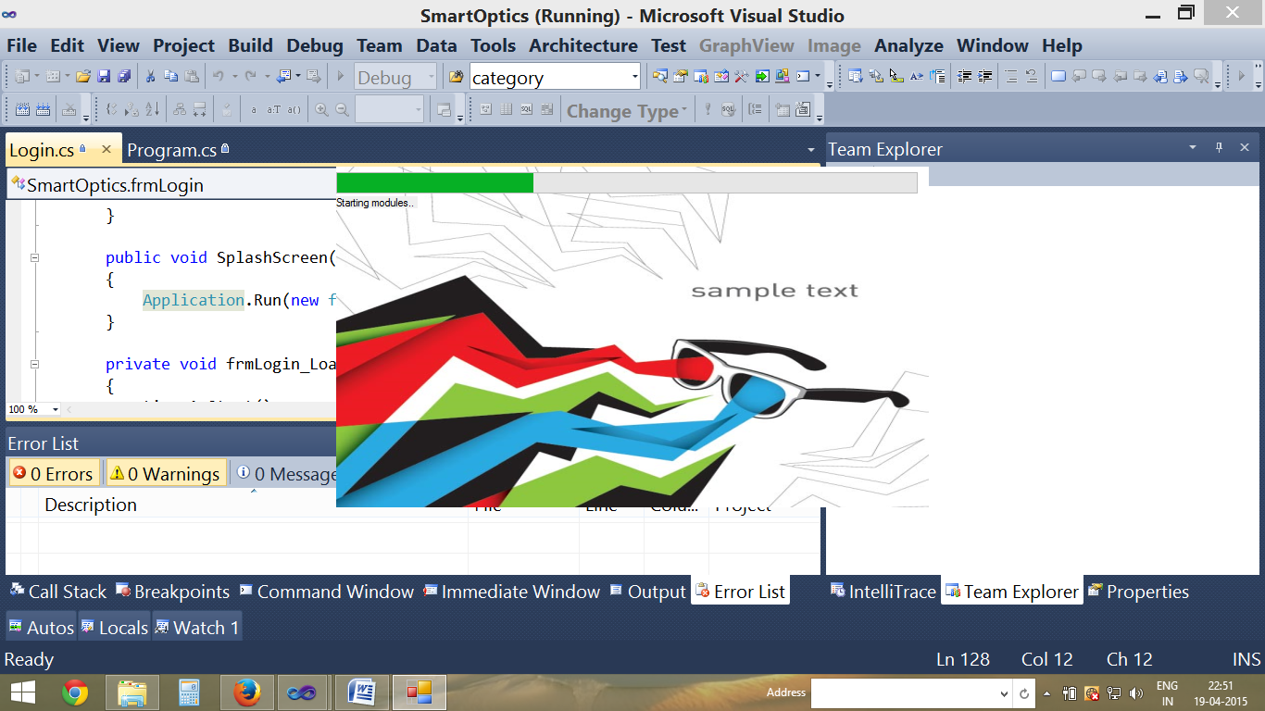

LOGIN FORM:

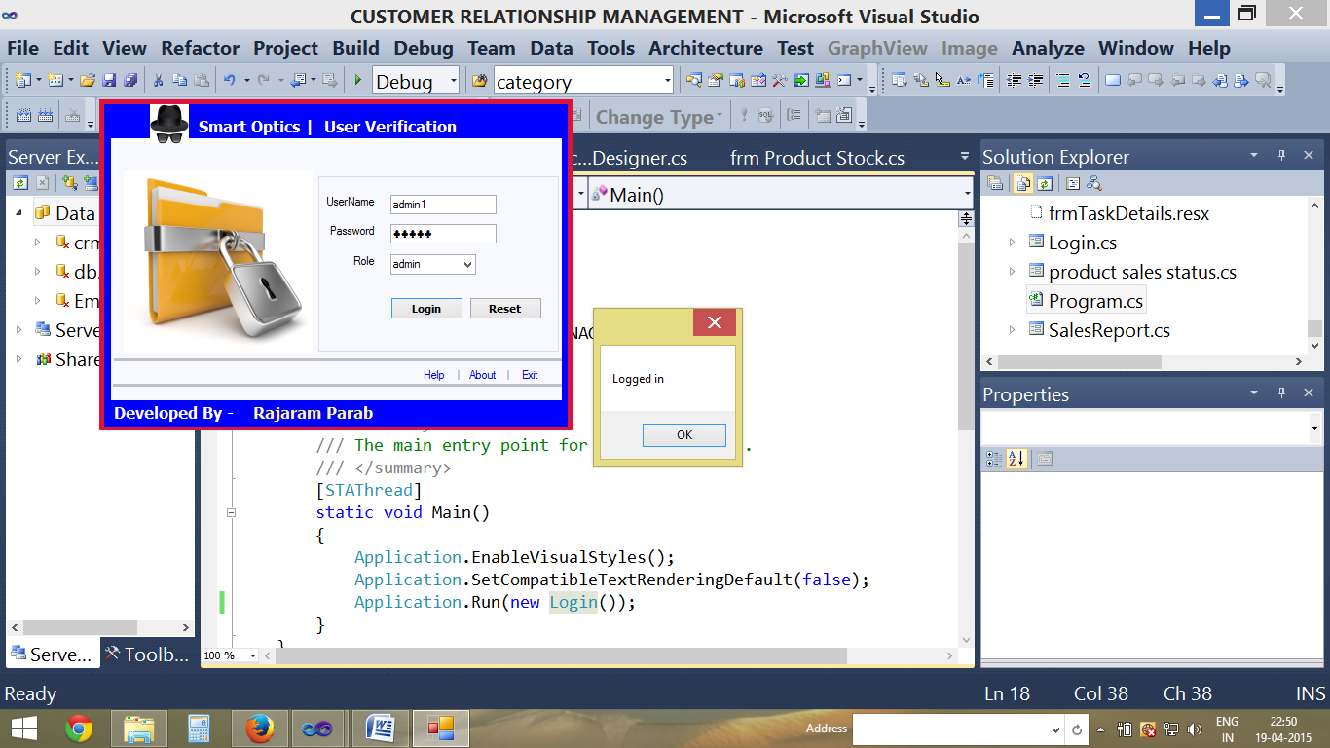

Customer DataFilling FORM:

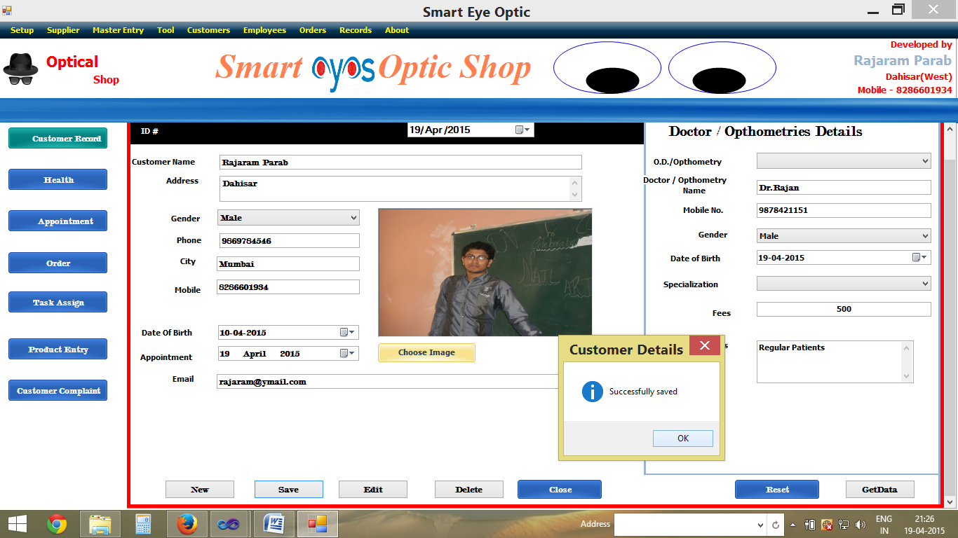

Customer Record FORM:

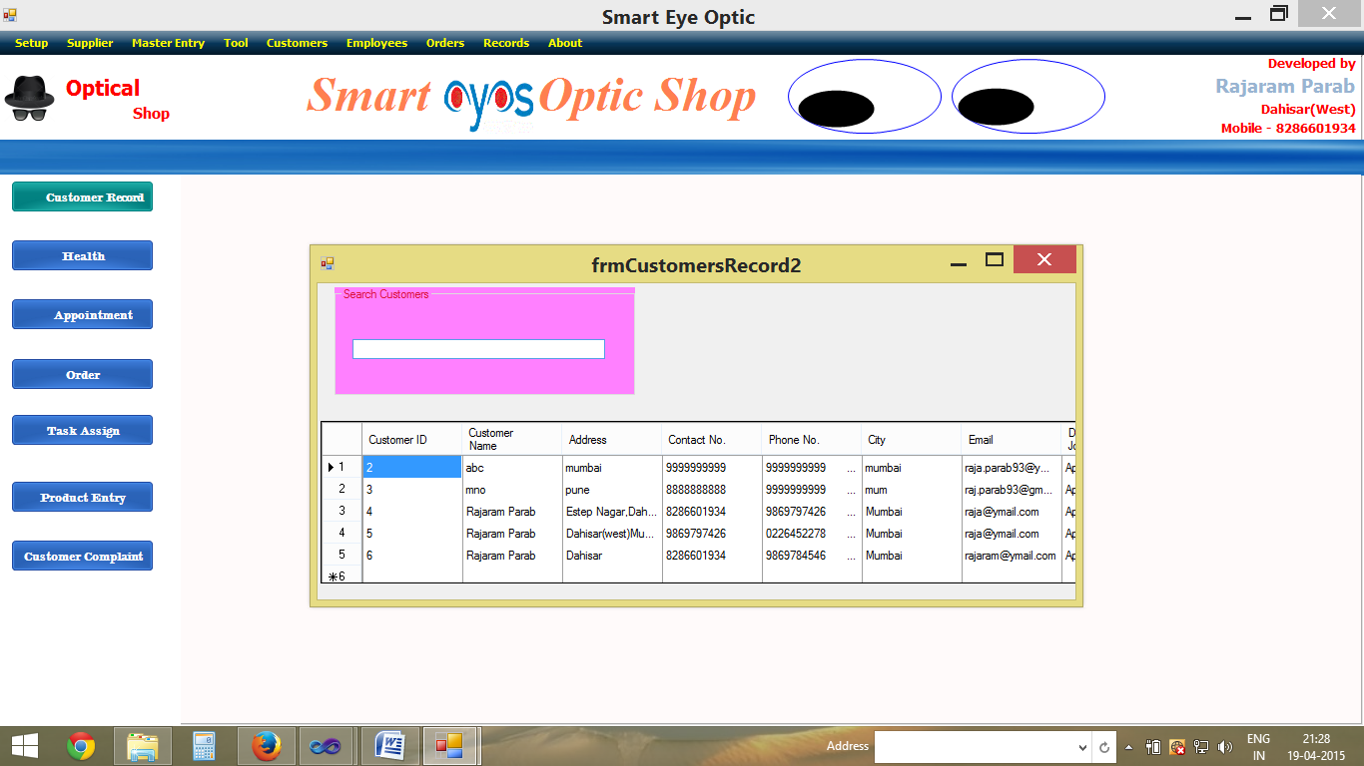

Customer Eye Data FORM:

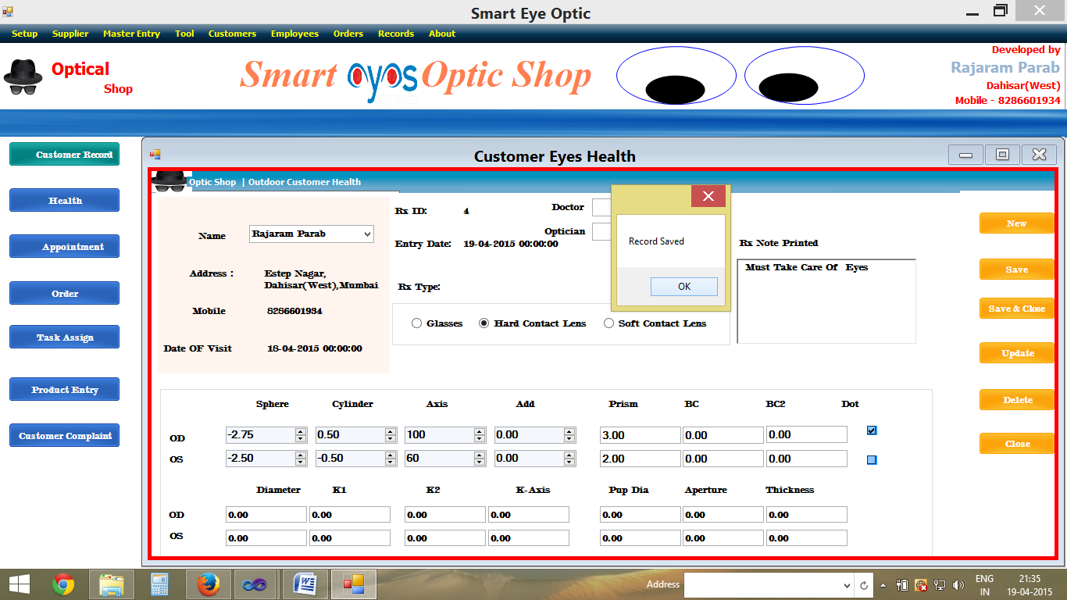

Category FORM:

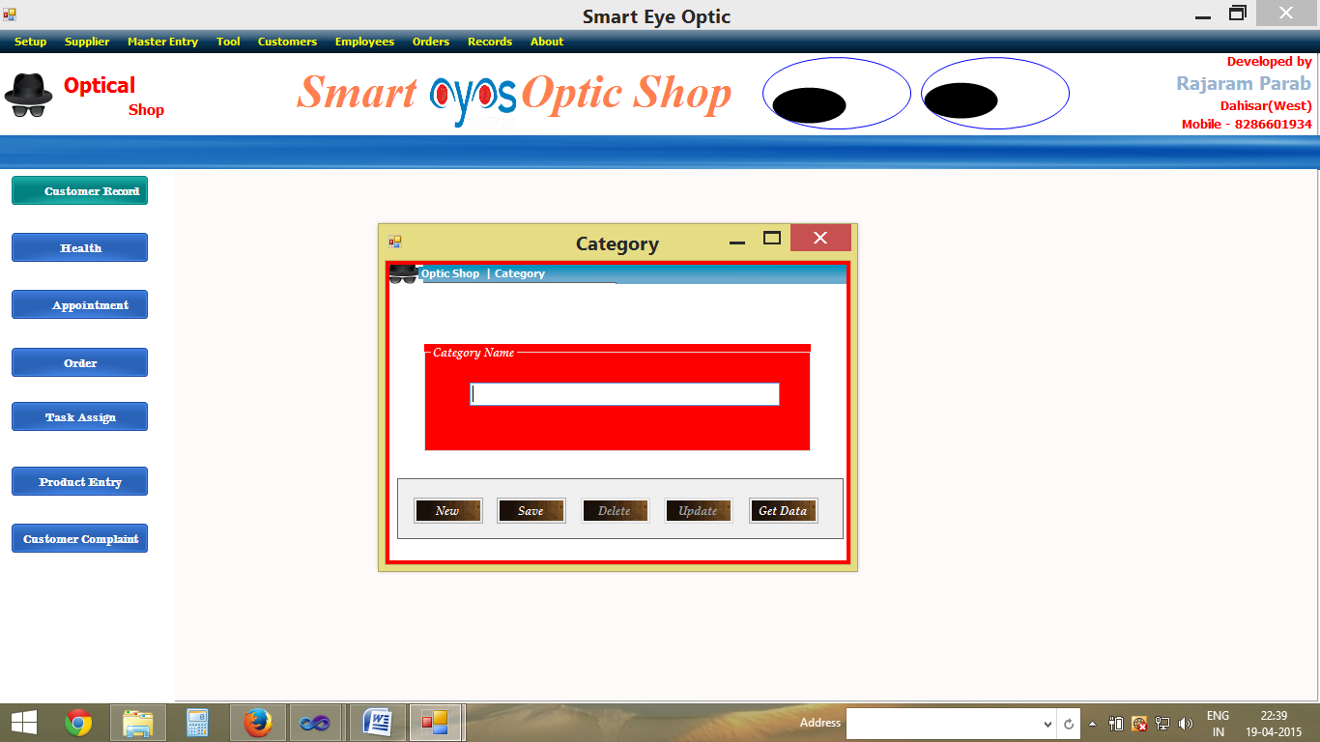

Subcategory FORM:

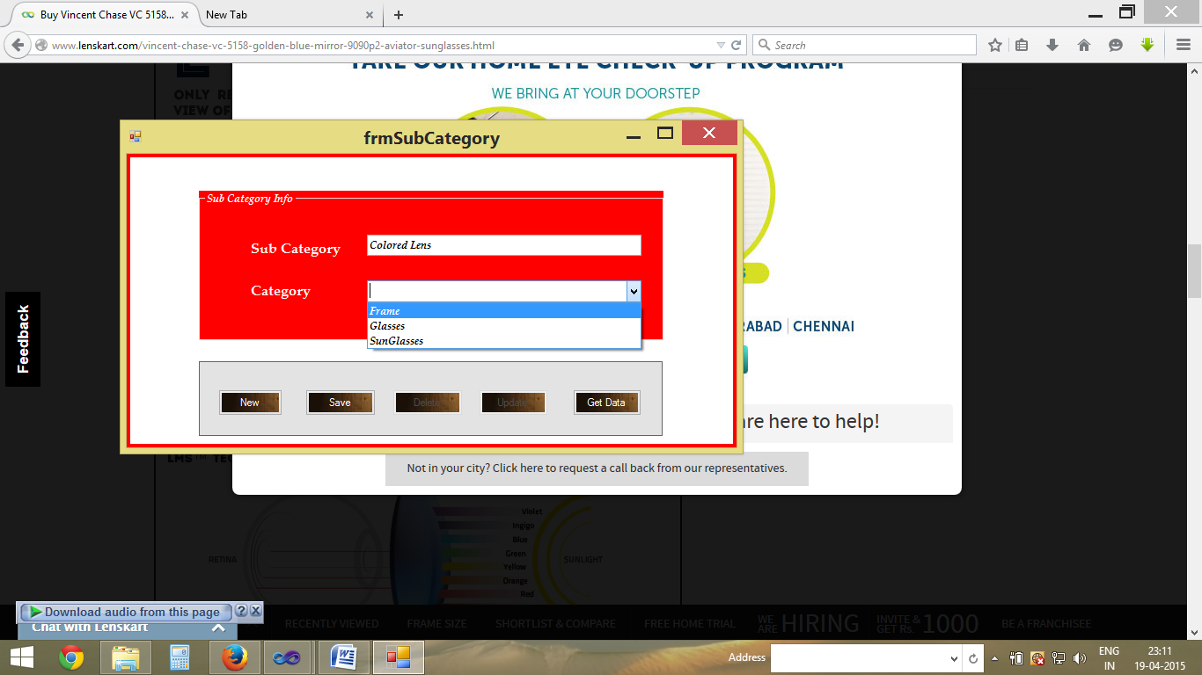

Appointment FORM1:

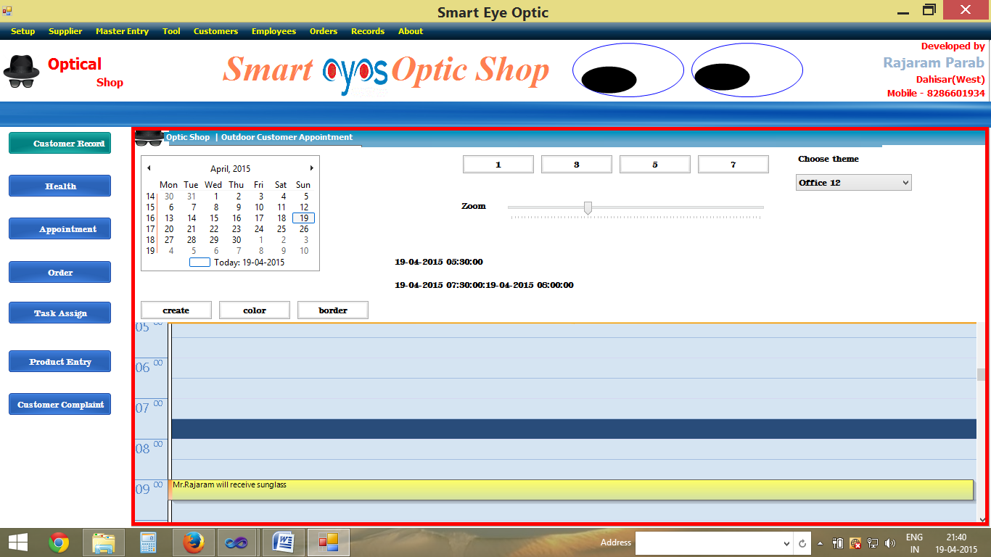

Appointment FORM2:

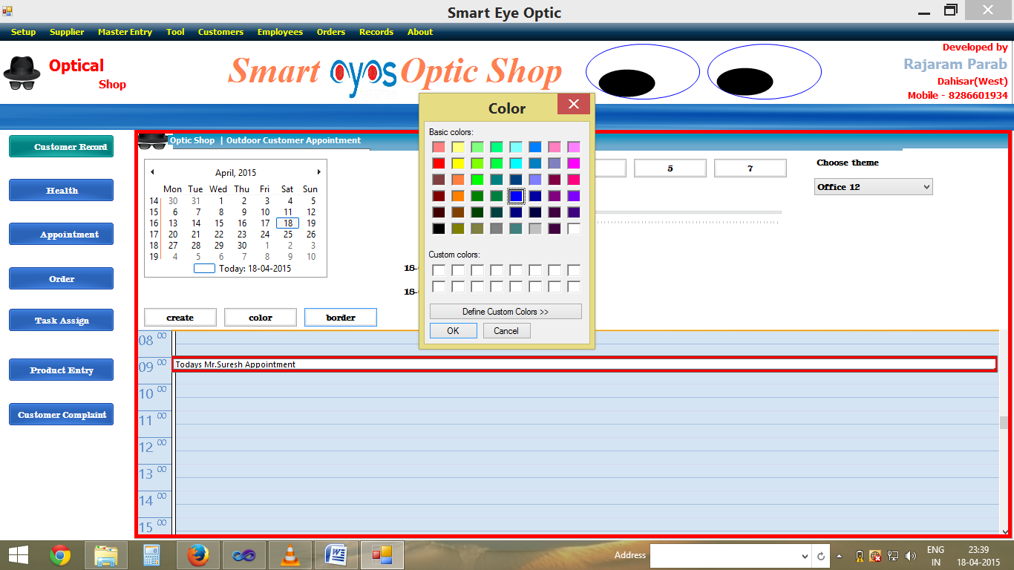

Product Data FORM:

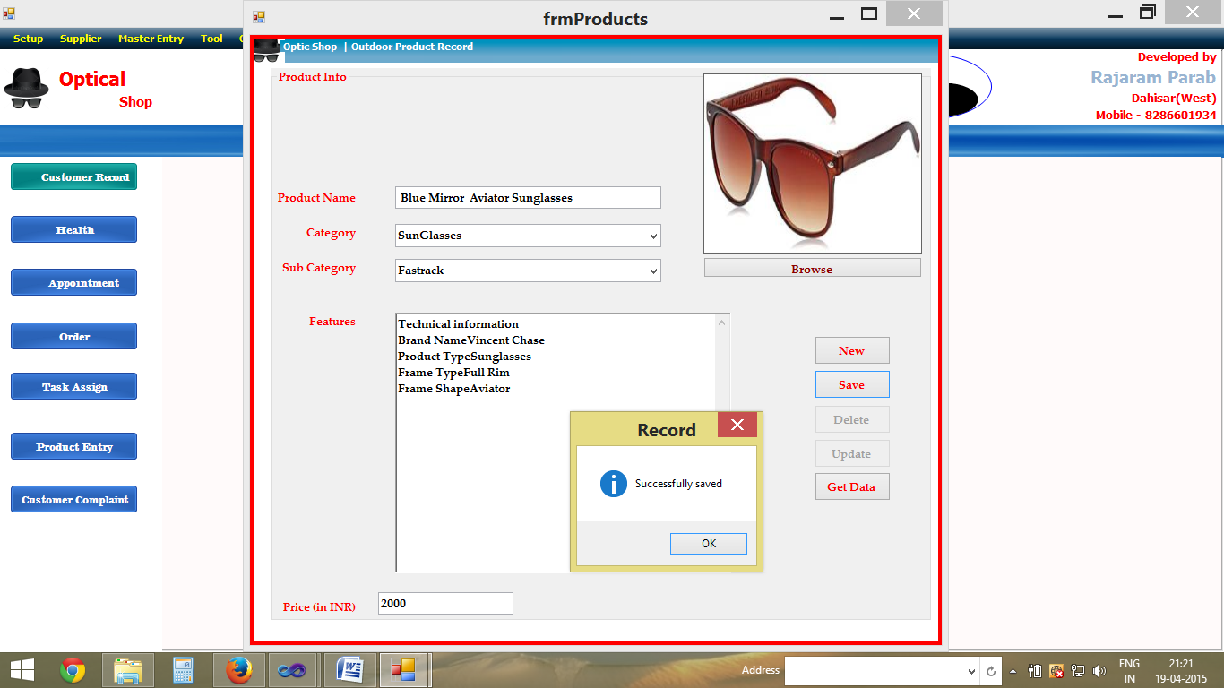

Product Record FORM:

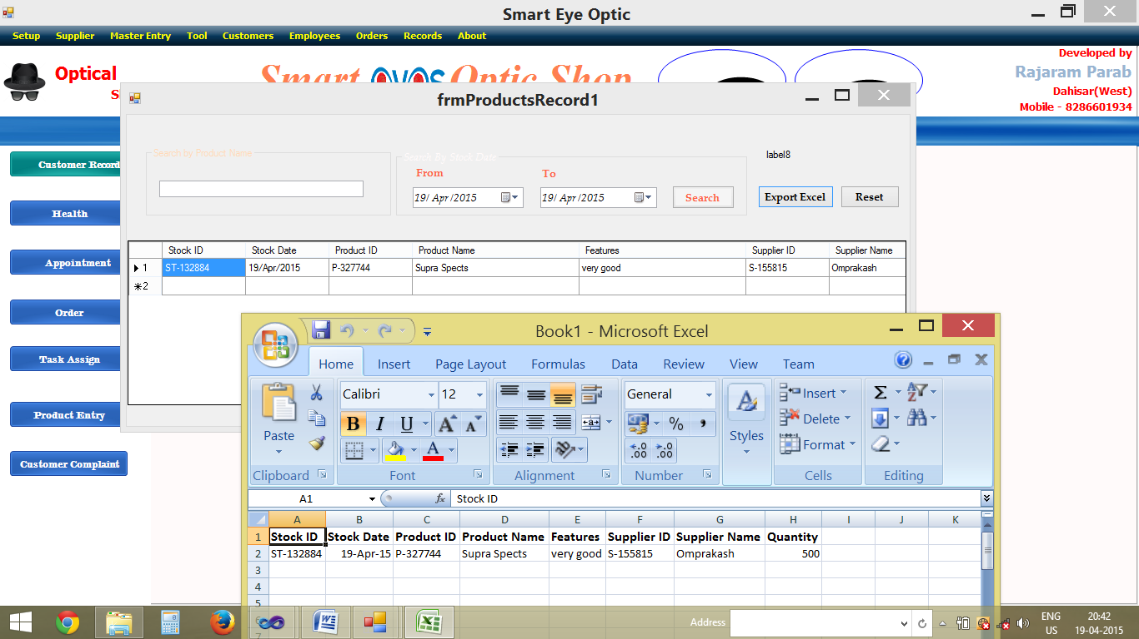

Suppliers Data FORM:

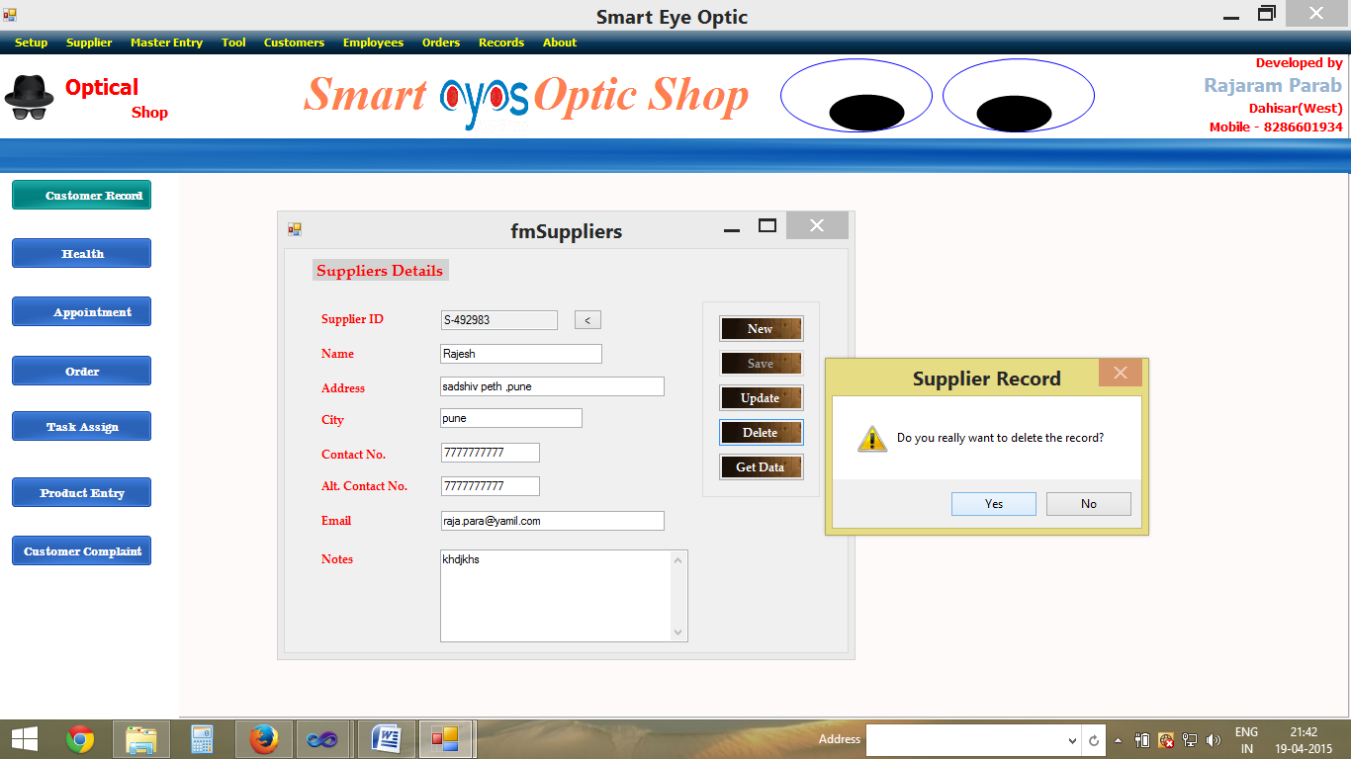

Suppliers Record FORM:

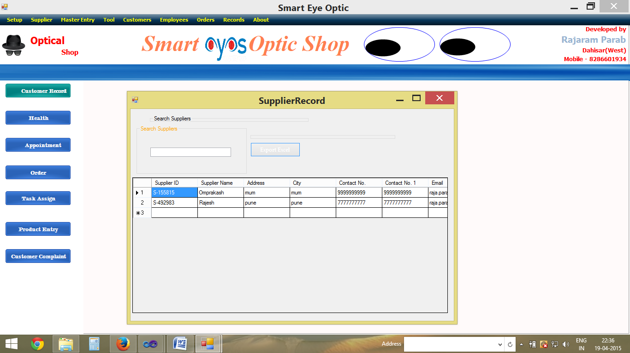

Stock Data FORM:

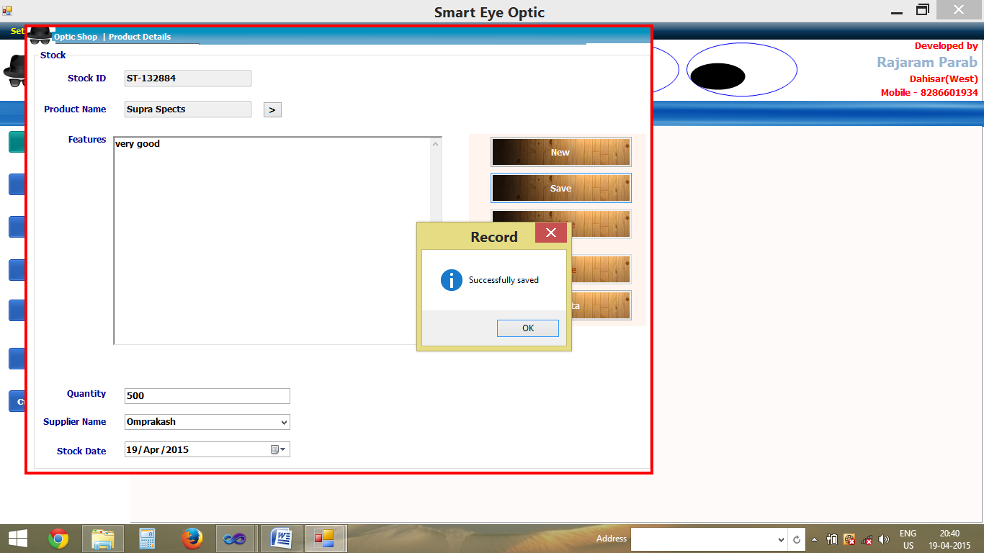

Employee DataFilling FORM:

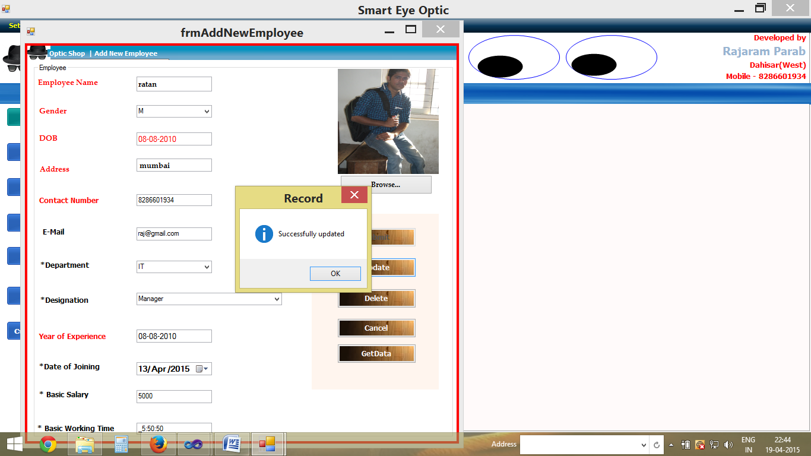

Employee Record FORM:

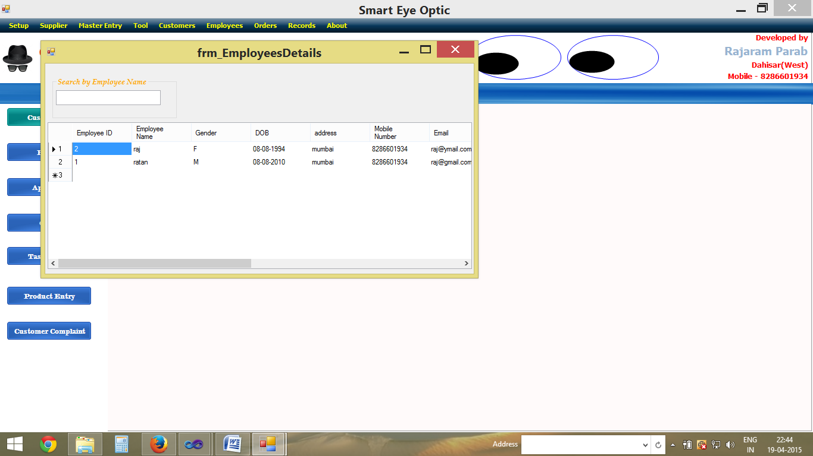

Customer Order FORM:

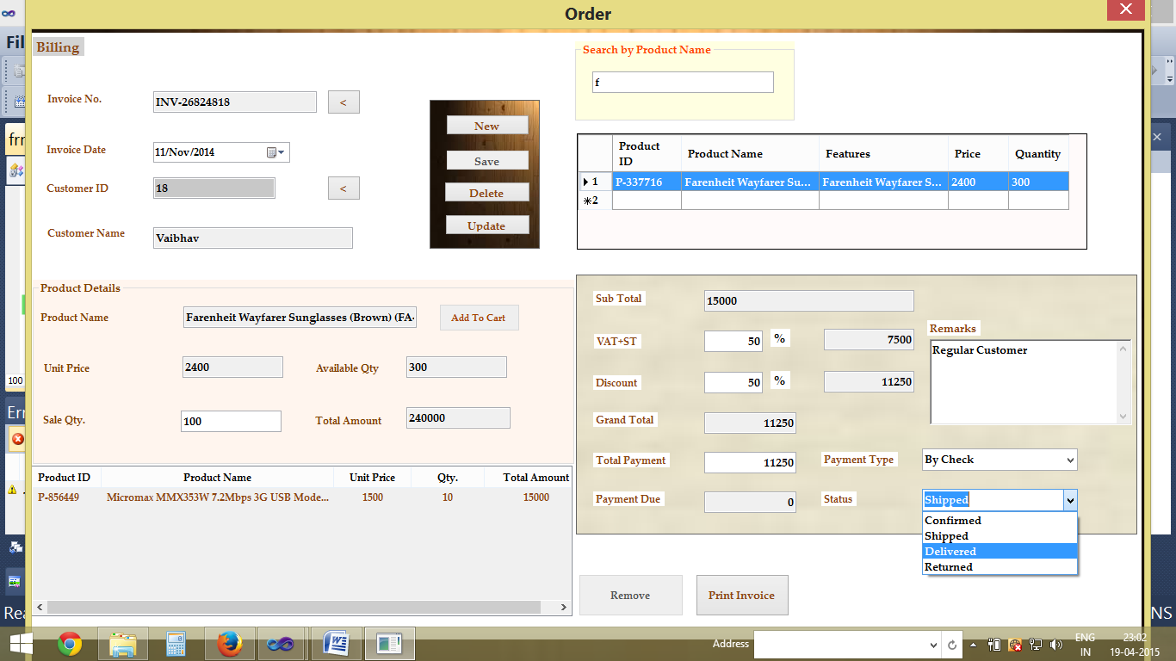

Sales Records FORM:

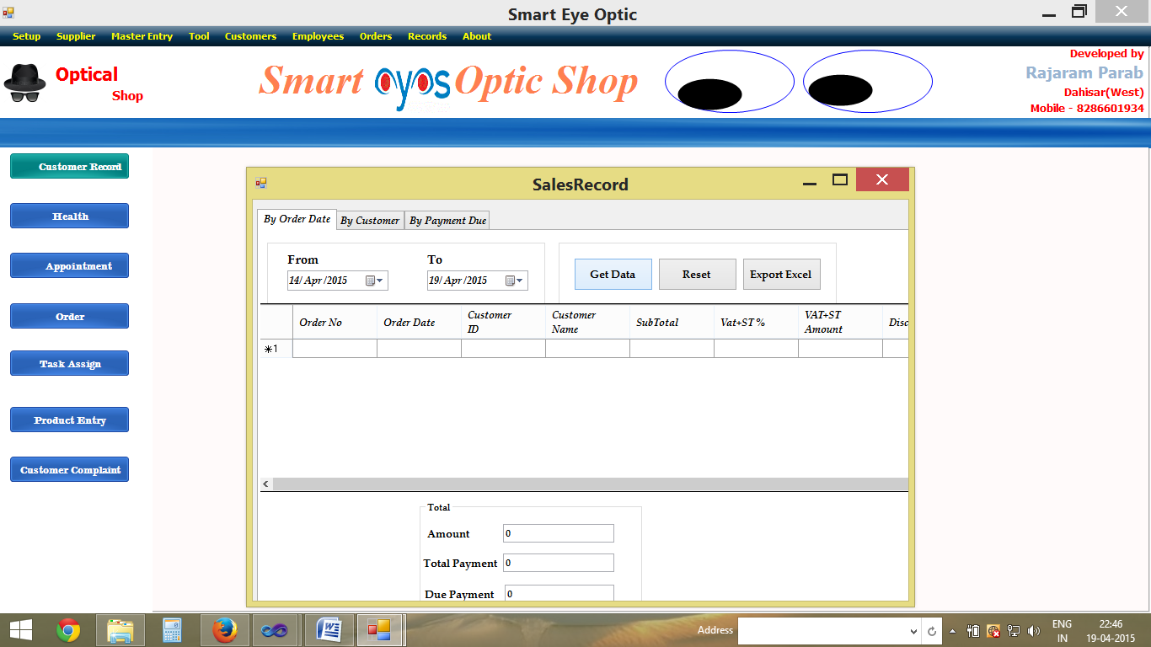

Sales Records FORM

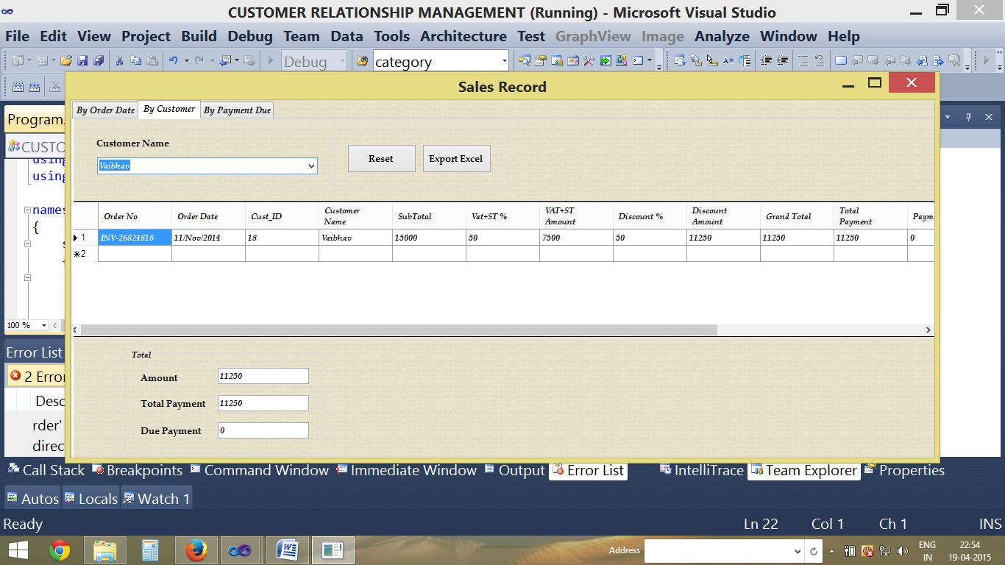

Sales Report FORM

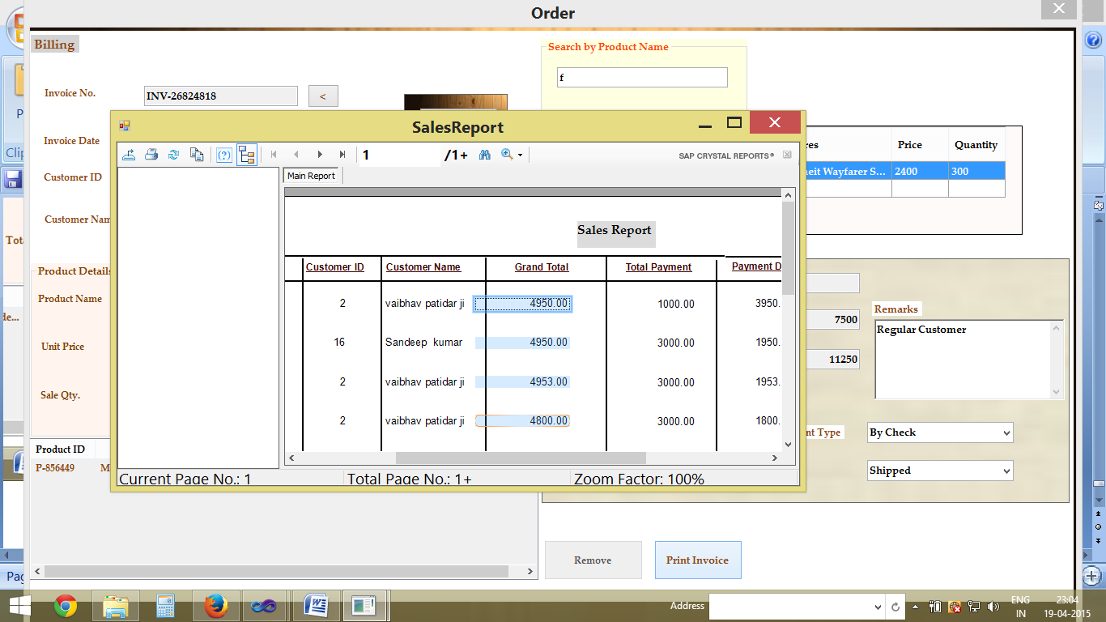

Customer Complaint FORM

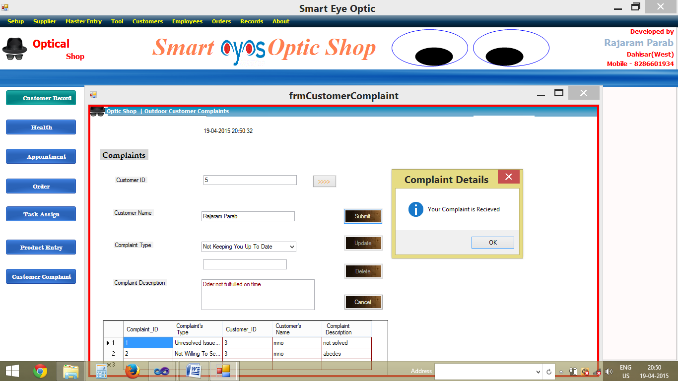

Assigning Task FORM

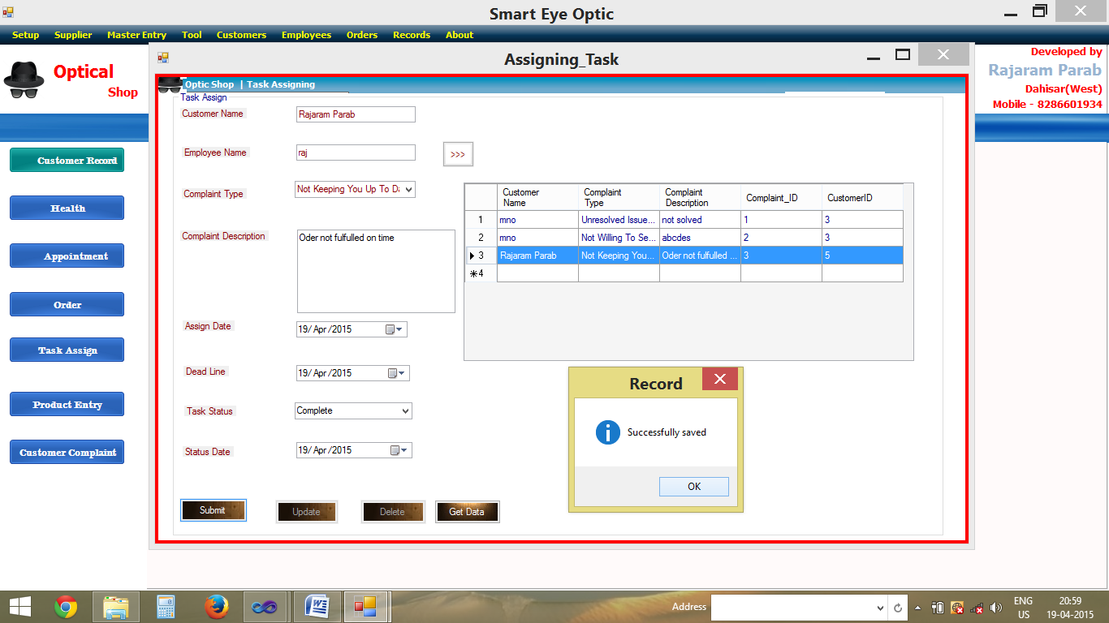

Task Detail FORM

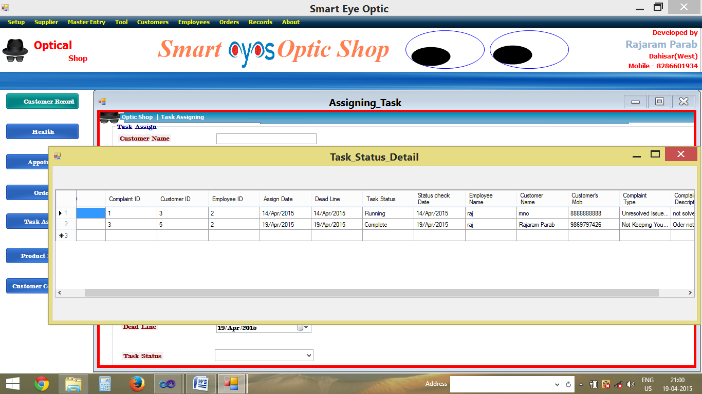

Other Utility Tools

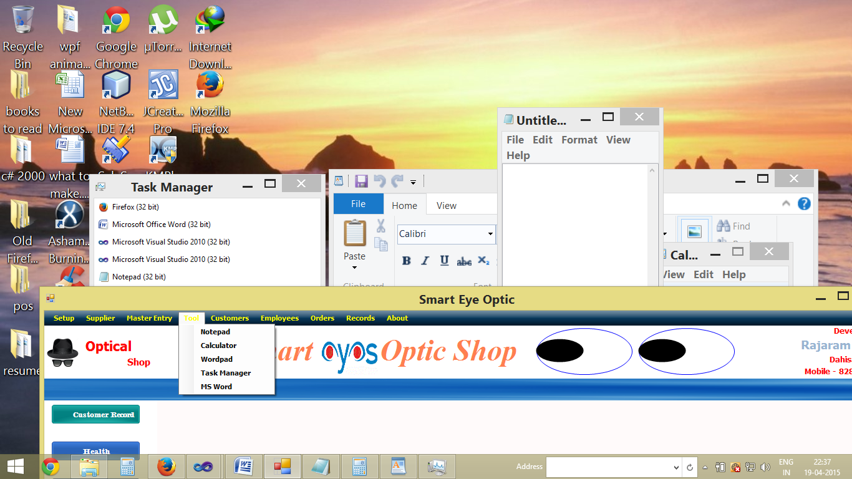

Entity Relation Database 1

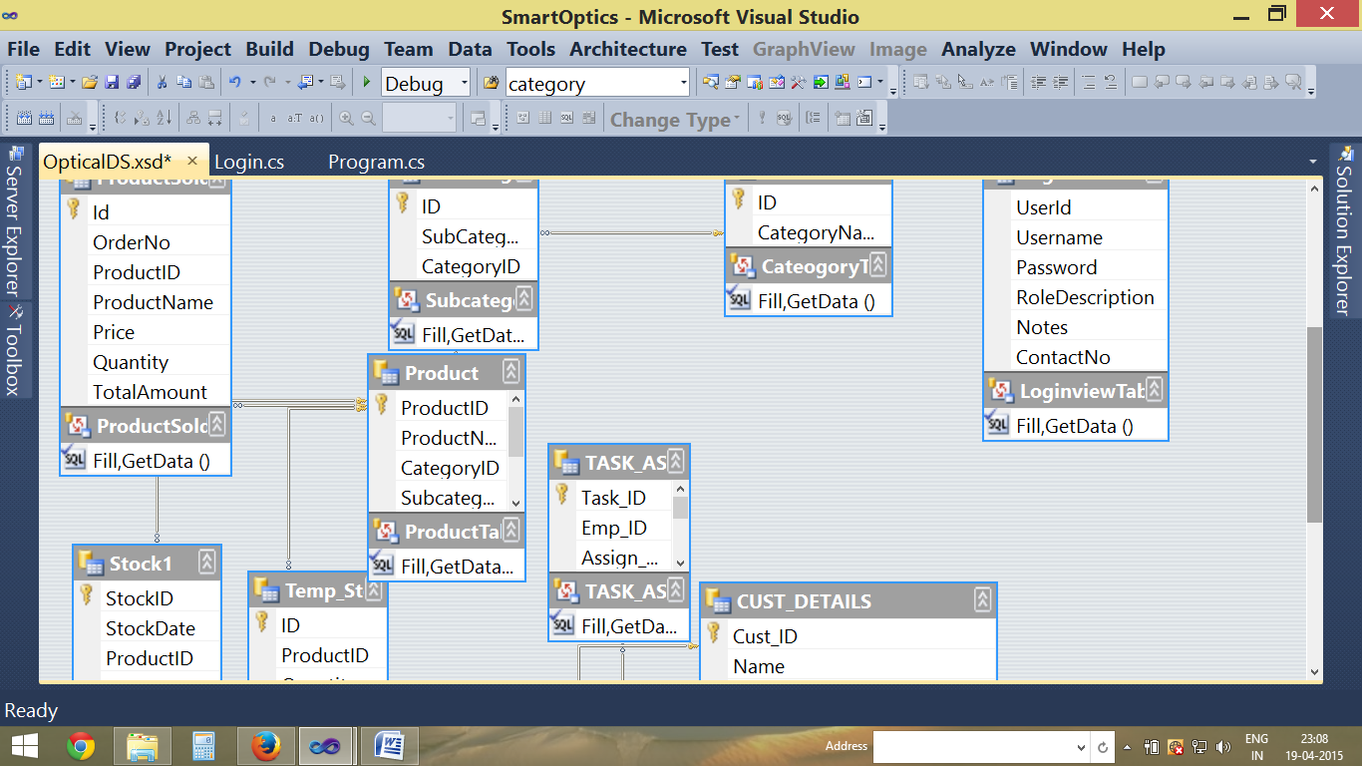

Entity Relation Database 2

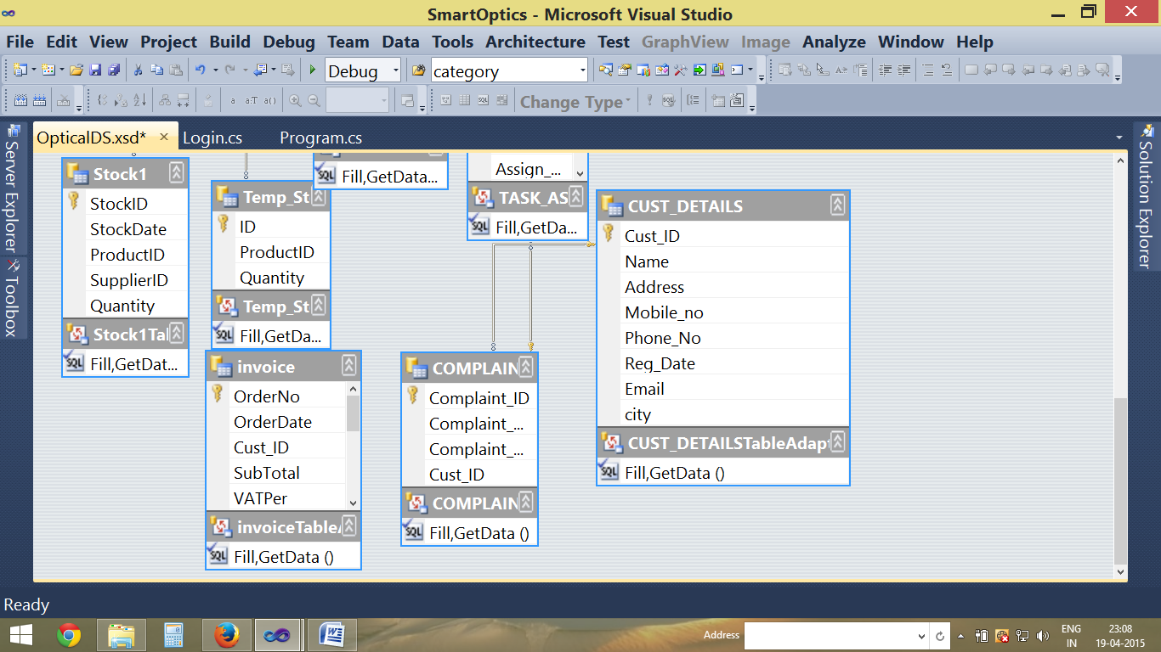

**CHAPTER 5**

**User Manual**

**4.1 User Manual**

When you meet our application you will see the main page. By simply clicking on the available links which are vertically & horizontally listed you can request for the page. After going to that page you have the links available to return to previous page or to Main page.

On the feedback form if you are interested to post your comment, suggestion or complaint about the system or application by filling all the fields in the specified format you can post.

Helper Manual for user will soon be provided in future update

**CHAPTER 6**

**LIMITATIONS**

**LIMITATIONS:**

* The User should take care while using this information as it is not full-fledged Application there is no proper backup of his database.
* It has not been texted on other platform (only for Windows use).
* Most of the analysis and interpretations, made for this report, are based on secondary data obtained. This data could have some inherent mistakes and errors.
* Some of the respondents were reluctant to part with certain information on the pretext of the sensitivity of the information. Also some facts of figures were not divulged as the company policy came in the way for free revelation of the desired input

**CHAPTER 7**

**CONCLUSION**

**CONCLUSION:**

This project has been a rewarding experience in more than one way. The entire project work has enlightened to me in the following areas.

* I have gained an insight into the working of the Optical Shop. This represents a typical real world situation.
* My understanding of database design has been strengthened this is because in order to generate the final reports of database designing has to be properly followed.
* Scheduling a project and adhering to that schedule creates a strong sense of time management.
* My inner sense has developed and confidence of handling real life project has increased to a great extent.
* Initially, there were problem with the validation but with discussions, I implement validations.

**CHAPTER 8**

**BIBLIOGRAPHY**

***Websites:***

|  |
| --- |
| * [Borland C#Builder Developer Resources](http://www.csharpbuilder.info) |
| * [BrainBell.com](http://www.brainbell.com/tutors/C_Sharp/) |
| * [C Programming](http://www.cprogramming.com/cgi-bin/cdir/Cdirectory.cgi?action=Category&CID=9&Page=2) |
| * [C# (C sharp): Microsoft Forum at Tek-Tips](http://www.tek-tips.com/gthreadminder.cfm/lev2/4/lev3/32/pid/732) |
| * [C# Code Examples](http://phoenix.liu.edu/%7Emdevi/) * [www.google.com](http://www.google.com) * [www.youtube.com](http://www.youtube.com) * www.c#helper.com |

***Professor Guide***

**Madam. Usha Phadatare**